Luis Morales
CSCI 4321 - Computer Security
October 8, 2025
Lab 05 – Packet Sniffing and Spoofing Lab

For Lab 5 we first needed to set up a network in docker:
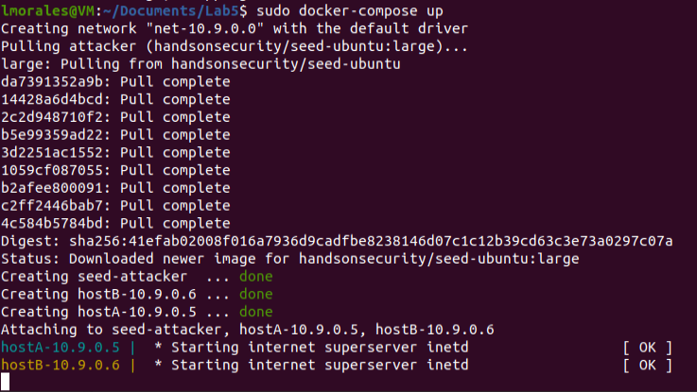

‘ifconfig’ was used to obtain the interface located at 10.9.0.1 (br-9c30b8bbbc0f)
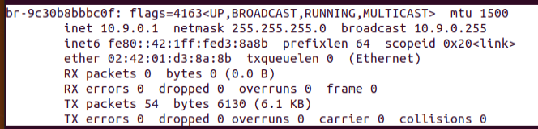

TASK 1 – Sniffing
mycode.py file was created with the correct interface name:
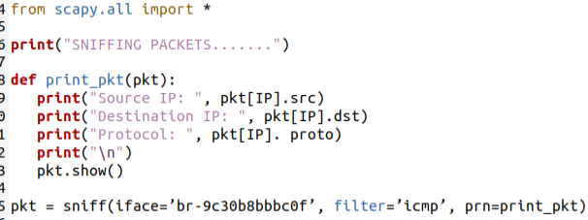
And the packet sniffing began:
While sniffing we will have the 2 hosts pinging each other to generate traffic:
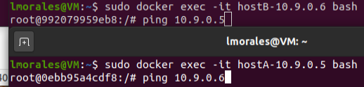
The results from the sniffing:
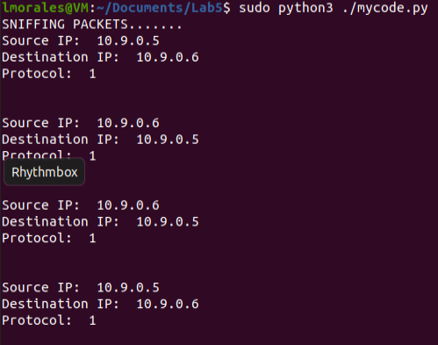
Capturing tcp traffic:
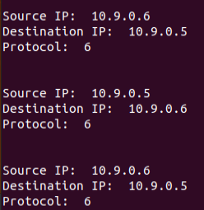
tcp traffic to/from any subnet:
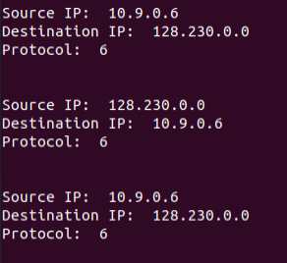

TASK 1.2 – Spoofing

Here is a demonstration of a spoof of an ICMP echo request packet with an arbitrary source IP address: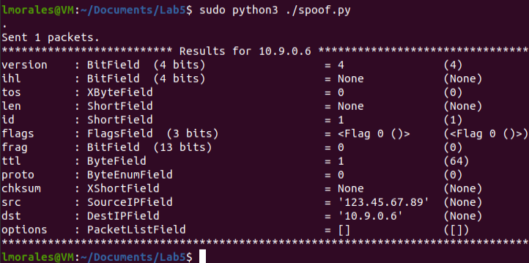

Sniffing and spoofing:
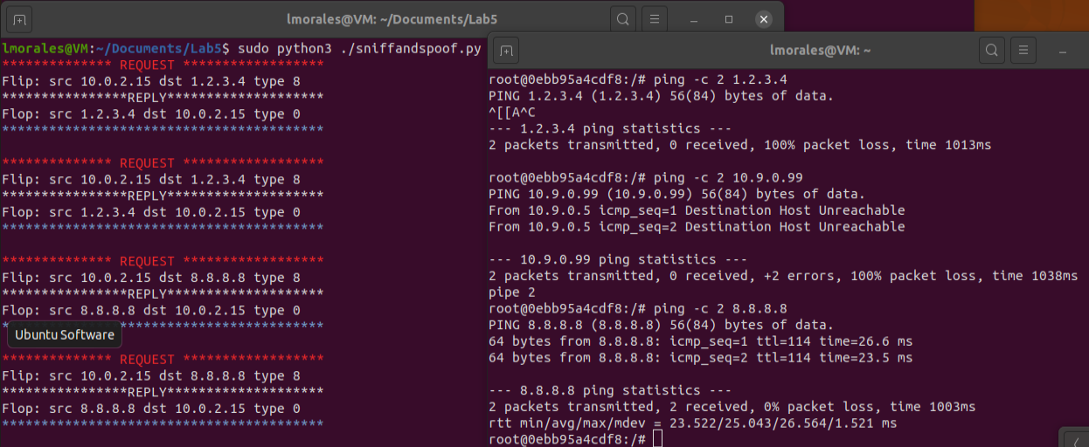

This was another interesting lab. I was not able to get WireShark to start for me. So I just used Scapy in a terminal window to track network traffic. The lab was pretty straightforward with little coding. I hope you don’t mind that towards the end I changed colors in the terminal to help split the printouts. I enjoyed the lab being so hands-on with both network sniffing and spoofing. I found in funny how spoofing can respond to pinging and make unreachable IP’s seem to be online. I’m sure I’m not the only one that has learned from this lab, that gave us a better understanding of how trust works in a network and how that trust can be used against the user at the packet-level.

